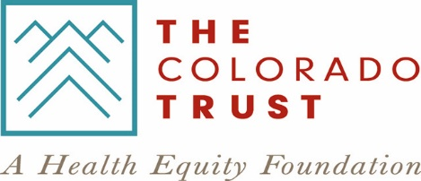

GENERAL SUPPORT GRANT REQUEST FOR AMENDMENT FORM
Grantees of The Colorado Trust are required to request approval to make any significant changes. Please refer to the Grantee Guidelines for more detail about these changes. Email this completed and signed form along with the required attachments to a Grants Management Specialist to ensure review of your request. If you have any questions, please contact us at 303-837-1200.
Organization Name:
Grant Number:
Primary Contact:

 | Amendment for increase or decrease of funds: Narrative attached
 | Check one: | Increase | Decrease |  | New Amount: $
 | No-cost extension of contract: Financial report for most recent reporting period, narrative for no-cost extension attached
 | From (current end date): |  |  | To (new end date):
 | Re-assignment of contract (e.g., new fiscal sponsor, new grantee, change in name, etc.): Completed Application Summary Form and IRS determination letter attached
Termination of contract: Written explanation for termination attached
Effective date of termination:
 | Other: Written explanation attached.

Name of Authorized Officer:
(authorized to sign for your organization)
Title:
Name of person completing this form:
Signature: |  | Date:

