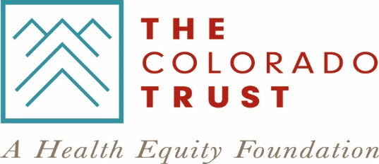

2018 Sponsorship Application

Event & Organization Information

Application date: Click here to enter text.

Do you have a Fiscal Sponsor? Select one: ☐ Yes / ☐ No

Tax ID Number (EIN): Click here to enter text.

Name of the nonprofit hosting the event, and contact information (including county):

Name: Click here to enter text.
Address (include city and zip code): Click here to enter text.

County: Click here to enter text.
Phone Number: Click here to enter text.
Website: Click here to enter text.

Email: Click here to enter text.

Contact information for the nonprofit’s event coordinator:
Coordinator name: Click here to enter text.
Phone Number: Click here to enter text.
Email: Click here to enter text.

Name, date and location of the event (including county):

Event Name: Click here to enter text.
Event Date: Click here to enter text.
Venue Name: Click here to enter text.
Venue Address: Click here to enter text.
County: Click here to enter text.

Event Questionnaire

- Please provide a brief description of the purpose of the event, as well as who typically attends the event.
Click here to enter text.

- What is your organization’s mission? Please explain how it aligns with The Trust’s health equity vision and the social determinants of health (e.g., income, employment, education, transportation, public safety, environment).
Click here to enter text.

- Please list the total number of people served by your organization/program in 2017 and, if applicable and/or known, describe communities and populations served.
Click here to enter text.

- What are the event sponsorship levels and benefits? Please list all available levels.
Click here to enter text.

- What is the sponsorship amount/level you are requesting?
Click here to enter text.

- Is this a fundraising or other type of event? (if “other,” indicate the type of event)
Click here to enter text.

Submission Instructions

Email the completed application as an attachment to sponsorships@coloradotrust.org. You will receive an email confirmation when your application is received, and will be notified thereafter whether your application was approved. Please allow up to 30 days for an approval decision from the time you submit your application. Your Tax ID Number (EIN) must be included on your application.

Incomplete information may result in your sponsorship request not being considered.

If you have questions, please contact Patricia Maynes at sponsorships@coloradotrust.org or (303) 837-1200 before submitting your application. Thank you!

